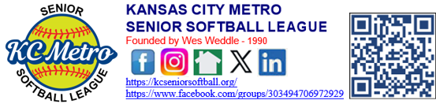

Board Meeting via Zoom: Sunday – July 26, @ 1:00 PM

Present at the meeting were Clint Berger, Paul Heacock, Bobby Gregg, Ann Willkett, Barry Gordon, Jeff Harlan, Susan Enyeart, Susan Scholler, Ed Stolz, John Dehan, John Mondi, Billy Boos, and Mark Kenney. Missing were Bob Fama (Mark Kenney has proxy) & Monte Johnson (Clint has proxy)

- Call To Order – Clint called the meeting to order at 1:02 pm.
- Read / approve minutes from June 28th - 2026 meeting – Susan made a motion to approve the minutes. Seconded by John Dehan. Passed 15-0-0.
- Treasurer’s Report - Paul – The reports were emailed out for everyone to review. Barry made a motion to approve the minutes. Seconded by Mark. Passed15-0-0. Paul had a question on what conferences were to have two sessions.
- COMMITTEE REPORTS [Default is “No Report” -- unless indicated with an “R,” for Report]:

- All Star Games / Picnic I. Manager’s / Player’s Survey Q. Rules & Protests
- Awards J. Marketing + Draft
- Board Nominations K. Membership Database / Dues + Men’s Competitive
- By Laws L. Military Service Wall + Women’s & Co-Ed
- Equipment / Safety / Health M. Mission Statement / Goals R. Social Media
- Finance N. New Members / Welcoming R S. Special Projects
- Legal / Risk Management O. Operations Notebook T. Sportsmanship
- Long Range Planning P. Player / Team Ratings U. Tournaments V. Umpires
N. New Members/Welcoming – Per Clint – Last year at this time we had 918 members, as of today we have 928 members.

- OLD BUSINESS:
- Day at the K – August 21st (Enyeart) – Susan Enyeart – Set for August 21st. We have received some great ticket prices. Susan will make up some fliers to hand out to the different conferences. Deadline will be August 7th. Susan will talk to Mason regarding the deadline.
- Red Cross – Susan is looking at November or January. Clint suggested we do January.

- NEW BUSINESS:
- All-Star Games / Picnic / Skills Contest / Swap Meet / Raffle -
  - Game info (start times, schedule, umpires, teams, etc.) – Bobby sent out the listing of game times and requests for All-Stars. Bobby, Clint, and Mark will get together about balls & screens and boards for home plate. We have the umpires per Bobby.
  - Skills Contests (equipment—bucket, balls, cones, etc.) – Clint to get the buckets and cones. Susan will make up the sheets.
  - Swap Meet?? – Barry – No need to try and put this on.
  - Raffle?? – Unless we get some items between now and then, we will not do the raffle this year
  - Food prep / service options for our picnic (figures for 280 attendees)
  - Just Another Catering Company:
    - $4,500 = Burgers / hot dogs, potato salad, and baked beans; and tea, lemonade, or infused water
- New Members Survey (Heacock) – Barry – contacted the new members on how they heard about or League. Sixty-five percent was from word-of-mouth; the other responses were from the Draft league. It looks like from this survey word of mouth has been the avenue. Barry asked for anyone to take over the social media side and did not get any takers.
- ½” thick HDPE plastic strike mats. HDPE is high-density polyethylene plastic—durable, uv-resistant, and moisture-proof. For outdoor projects—high heat stability, high impact strength, chemical & corrosion resistance. $273 for 5 – Clint – Has had great feedback on the wooden strike mats, other than the balls being damaged due to hitting the 90-degree edges/corners. Susan S and Susan E – warped board and umpires not looking at the arch only listening for the sound. Per Clint the wooden boards are no longer at Hartman as we cannot put them away, so they warp. Clint would like to purchase five of the HDPE strike mats and try them at Hartman and Independence. John Dehan made a motion to allow Clint to purchase five of the strike mats to test. Seconded by Susan E. Passed 15-0-0.

- Incumbent board members, whose terms are up -- Barry Gordon; Bobby Gregg; John Dehan; Susan Scholler; Monte Johnson). We need to start to find new nominees. – Bobby is out, Barry is in, John Devan is in, Susan Schiller is in and not sure about Monte – Clint will check with him. The following are possible recommended individuals to run for the board: Richard Hite, Allen Edwards, Mark Wurfel, John Shoebrook, Bob Shea & Mike Curley. Per Barry, we still need to be sure they agree with wanting to run.
- Coins – Barry – Would like to make up some coins that are like military coins. One side would have our KCMSSL logo, and the other side would have a military branch logo. Fifty of them would be one side is our KCMSSL logo, and the other side will have our “saying” on it. For 500 (100 each for the military branches (Army, Navy Air Force & Marines), fifty for Coast Guard, and fifty for our use. For a quantity of five hundred, the cost is $1,625.00. Bobby made a motion to move forward with the coins, seconded by Paul. Passed 14-1-0.
- Draft Conference - Barry wants to update everyone on the Draft conference. Currently we have 287 players. We have 2 days with eight teams, 1 day with six teams and 1 day with four teams.
- Sponsors – Barry – We do not have a sponsor to pay for the All-Star give aways or the championship shirts for the draft conference; however, it was in the budget to pay for these if we are not able to get a sponsorship.
- Ambassador Jackets – Barry/Paul – we budgeted for thirty new jackets and so far, only have applications for twelve. The applications still need to be looked over.

Items desired to be included in July Newsletter email blast (BOARD preferences / suggestions)- Ambassador Jackets, All Star picnic and games and the Day at the K.

SET DATE FOR NEXT MEETING - August 23, 2026, at 1:00 pm.

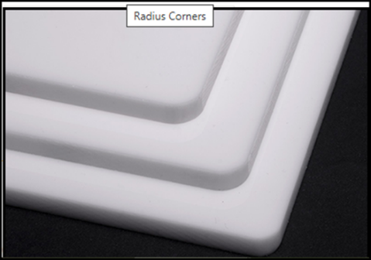 HDPE (plastic strike mats) beveled edges and rounded corners

John Dehan made a motion to adjourn the meeting, seconded by Ann. Meeting adjourned at 2:02 pm. Passed 15-0-0.

2026 2027 2028
Barry Gordon Jeff Harlan Clint Berger
Bobby Gregg John Mondi Bill Boos
John Dehan Bob Fama Ann Willkett
Susan Scholler Susan Enyeart Paul Heacock
Monte Johnson Ed Soltz Mark Kenney

