2026
Rules and Regulations

Established 1990
www.kcseniorsoftball.org






37th Season

The Kansas City Metro
Senior Softball League


Founded in 1990 by Wes Weddle, the league has grown to over 900 men and women on teams that play in conferences across the metropolitan area. We are the largest senior softball league in the nation, according to Senior Softball-USA.
Many volunteers—including the Board of Directors, conference coordinators, and members of various committees—log countless hours each year planning and organizing league activities.
This book contains the rules of our game and contact information for board members and conference coordinators. Wes Weddle
As we are affiliated with Senior Softball USA, we draw many rules from that organization. For any rule not spelled out in this book, please refer to the SSUSA rules posted online at seniorsoftball.com. In a situation not covered by our book or SSUSA, we follow the rules of USA Softball (formerly ASA).

Sportsmanship policy

The Board of Directors wishes all members a healthy, fun and civil season in 2025. To help encourage the “civil” part, the board asks everyone -- managers, players, umpires and spectators -- to treat each other with respect, even when disagreements arise.

Please follow these basic sportsmanship tenets:

- Show respect for the opponent at all times.
- Show respect for the umpires.
- Know, understand, and appreciate the rules of the contests.
- Maintain self-control at all times.
- Recognize and appreciate skill in performance regardless of affiliation.

As Wes Weddle was fond of saying: “Remember, if you play the game, have a good time, and lose, you are still a winner.”

“We don’t stop playing because we grow old...we grow old because we stop playing.”
-George Bernard Shaw-

To view a list of KCMSSL members who have died,
go to the league website:
www.kcseniorsoftball.org

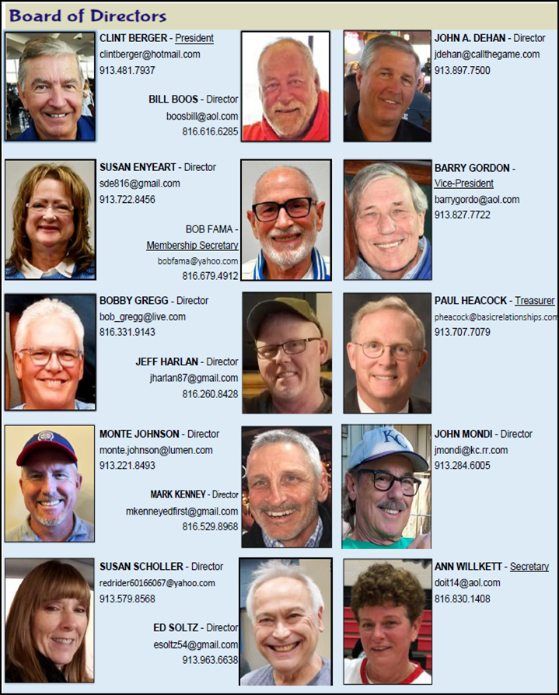

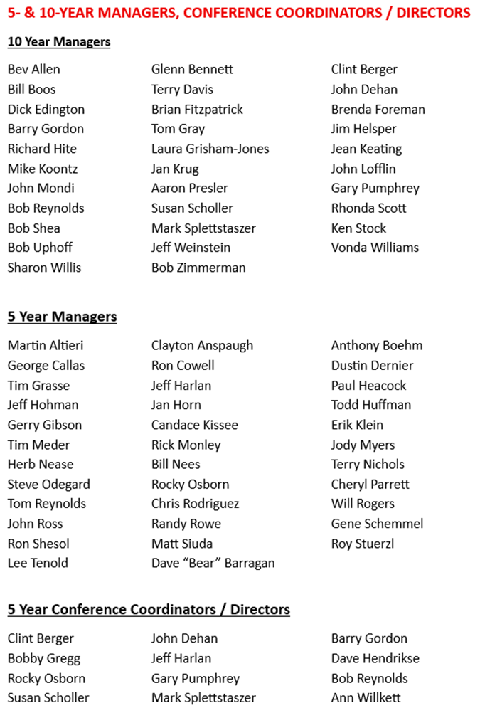

TABLE OF CONTENTS
Page
Board of Directors and Committees………………………………... 2
Conferences Coordinators…………………………………………... 3
Definitions (Article I)……………………………………………….... 5
Affiliation (Article II)………………………………………………… 7
Player Eligibility (Article III)………………………………………... 7
Dress Code (Article IV)……………………………………………… 8
Playing Rules (Article V)……………………………………………. 8-9
Solicitation………………………………………………………… 8
Conduct……………………………………………………………. 8
Lightning Policy……………………………………………………9
Smoking Policy……………………………………………………. 9
Alcohol Policy……………………………………………………...9
The Game (Article VI)……………………………………………….. 9-20
Divisions and Player Ratings……………………………………… 9
Borrowing Players………………………………………………… 11
Injured players…………………………………………………….. 11
Starting Count……………………………………………………... 12
Batting Lineup…………………………………………………….. 12
Game Length………………………………………………………. 12
Flip Flop Rules…………………………………………………….. 12
Home Runs…………………………………………………………13
Pitching Screen……………………………………………………..13
Ground Rule……………………………………………………….. 14
Tie Games…………………………………………………………. 14
One Pitch Extra Inning………………………………………………15
Tie-Breakers……………………………………………………….. 15
Equipment…………………………………………………………. 15
Re-Entry and Extra Players……………………………………….. 16
Number of Players………………………………………………… 16
Borrowed Players………………………………………………….. 16
Team Rosters……………………………………………………… 17
Line-up Slips………………………………………………………. 17
Game time…………………………………………………………. 17
Base running — courtesy runners, sliding, plays at home………… 18
American with Disabilities Act……………………………………. 19
Ineligible Players and Protests…………………………………….. 20
Batting Position Rule……………………………………………... 20
Specific conference rules
Women’s Conference……………………………………………… 20
Draft Conferences…………………………………………………. 21
Protest Form…………………………………………………………. 26
Field Specifications………………………………………………….. 27-28
RULES AND REGULATIONS
OF
THE KANSAS CITY METRO SENIOR SOFTBALL LEAGUE INC.
http://kcseniorsoftball.org

A. BOARD OF DIRECTORS (must be league members):

Bobby Gregg (’26), 816-288-0704
Barry Gordon (’26), Vice President, 913-827-7722
Susan Scholler (’26), 913-579-8568
John A Dehan (’26), 913-897-7500
Monte Johnson (26), 913-221-8493
John Mondi (’27), 913-284-6005
Jeff Harlan (’27), 816-260-8428
Bob Fama (’27), Membership Secretary 816-769-4912
Ed Soltz (’27), 913-491-0575
Susan Enyeart (’27), 913-722-8456
Clint Berger (’28), President, 913-481-7937
Ann Willkett (’28), Secretary, 816-830-1408
Paul Heacock (’28), Treasurer, 913-707-7079
Mark Kenney (’28), 816-529-8968
Bill Boos (’28), 816-616-6285

B. COMMITTEES and chairs
President and vice president are ex officio members of all league committees.

All Star Games/Picnic – GREGG; Boos, Willkett, Johnson, Fama, Brad Uecker, Mike Curley, Tony Lenci
Awards – GORDON; Gregg
Board Nominations – BERGER; Gordon
By Laws – SCHOLLER; Soltz, Gary Pycior, Michelle Ciafullo
Equipment/Safety/Health – KENNEY; Berger, Fama, George Kramer,
Finance – HEACOCK, (Denny Williams – Asst. Treasurer); Ray Harre, Bob Dona, Jim Glynn
Legal/Risk Management – HEACOCK; Soltz, Mike Curley, Jim Mueller
Long Range Planning – DAVE HENDRIKSE; Scholler, Heacock, Gary Pycior
Membership Survey – BERGER; Gordon, Gregg, Willkett, Scholler, Harlan, Mark Splettstaszar, Mike Koontz, Gary Pycior, Joe Palermo
Marketing & Recruiting – DAVE HENDRIKSE; Mondi, Gordon, Enyeart, Gary Pycior, Mike Curley, Brad Anderson, Bill O’Neil, Alan Edwards, Greg Tarr, Bill Boos, John Dehan
Membership Database/Dues–GORDON; Berger, Harlan, Jim Chastain Mission Statement/Goals – HEACOCK; Kenney, Jim Chastain
New Members/Welcoming – BERGER; Gordon, Kenney, Tim Meder
Operations Notebook – GORDON; Berger, Mike Curley, Dave Hendrikse
Player/Team Ratings – BERGER; Gregg, Jim Chastain, Jack Allen, Gary Pycior, Mike Peel
Rules & Protests
Women’s & CO-ED - WILLKETT; Scholler, Enyeart
Men’s Competitive; - BOOS; Dehan, Harlan, Johnson, Bill Nees, Mark Splettstaszer, Richard Hite
Draft - GREGG; Gordon, Mondi, Mike Curley, Ray Harre, Jim Chastain, John Lofflin, Dave Hendrikse, Richard Hite
Social Media – MONDI; Enyeart, Terry Cloutier, Jim Chastain, Terry Nichols, Gary Pycior, Dave Hendrikse
Special Projects – SCHOLLER; Kenney, Enyeart, Steve Krull, Tony Lenci, Kathy Kochersperger
Sportsmanship – DEHAN; Harlan, Johnson, Kenney
Tournaments – GREGG; Boos, Gordon, Berger, Willkett, Gary Pycior
Umpires – DEHAN; Scholler
Military Service Wall - MONDI, Berger

NOTE: ALL CAPS indicates committee chairperson. Next listings are board members on that committee. The smaller font listing of name references non-board members who have requested to, or agree to, assist with the subject committee.

C. CONFERENCE COORDINATORS:
Each conference coordinator serves as a liaison between the conference and the Board of Directors. All coordinators are either board members or report to a board member. The coordinators communicate with team managers, make sure all players are league members, and help with scheduling issues. They distribute softballs to the teams or park staff, encourage managers to follow team dress codes, and make sure equipment provided by the league is in good working order. They cannot make rule changes for their conference without board approval, and they cannot spend league funds without board approval.

Coordinators:

Sunday:
Black Bob (Olathe) John A. Dehan
Monday:
Hartman (Lee’s Summit) Susan Scholler/Ann Willkett
Frank White Complex (Lee’s Summit) John Hendel/Mick Fletcher
Independence Athletics Complex Gary Pumphrey
Tuesday:
Independence Athletics Complex Bob Reynolds/Tom Reynolds/Mike Reynolds
Black Bob 50/55+ (Olathe) Dale Filsinger/Duane Peitz
Black Bob 65/65+ (Olathe) James Carter
Black Bob 70/75+ (Olathe) Ed Soltz
Wednesday:
Hartman (Lee’s Summit) Jeff Harlan
Thursday:
Heritage (Olathe) Monte Johnson
Frank White Complex (Lee’s Summit) Paul Heacock/John Hendel
Hartman (Lee’s Summit) Debbie Brown
Saturday:
Roe Park-Draft (Overland Park) Gary Pycior/William Wallisch

ARTICLE I. DEFINITIONS
Note: For simplification of rule wording, all pronouns in this book refer to male and female players, managers and umpires.

BORROWED PLAYER: A current paid member from another KCMSSL team that will be filling in on your team. Borrowed players must meet the age and age-adjusted rating equal to or lower than the team’s rating. Borrowed players must play catcher, right field, or right center field for teams with 11 defensive players or catcher or right fielder for teams with 10 defensive players and bat last in the lineup from the beginning of the game. If a borrowed player does not play one of the above-referenced positions, two (2) runs will be awarded to the opposing team at the beginning of the game.

COMMITMENT LINE: A six-foot line marked thirty feet from home plate, perpendicular to the foul line between third base and home plate. Once a runner’s foot touches the ground on or past this line during a live ball, the runner may not re-cross the line in the direction of third base. The runner must continue toward the scoring plate. Violation will result in a live ball out.

CONFERENCE: A group of teams playing at a specific facility on the same day of the week under the sponsorship of the KCMSSL. Not to be confused with the League (KCMSSL).

Courtesy Runner: A rostered or borrowed player that is allowed to run the bases for a player that safely earns their way on base with a hit, walk, etc.

Designated Runner: A rostered or borrowed player that has been designated to run for a specific player from home each time that player is up to bat. A designated runner cannot also be a courtesy runner. The designated runner can run more than once in the inning should the lineup bat around.

DIVISION: A group of teams forming part of a conference, determined by the League to be of generally comparable playing abilities, that play a schedule of games among themselves.

DOUBLE BAG FIRST BASE: A two-colored double bag that has equal sizes on either side of the foul line, with the white portion in fair territory and an orange or other colored bag extending into foul territory.

On extra base hits, errors, or balls hit to the outfield, the batter-runner may touch either portion of the bag. Should the batter-runner round the base, he may return to either portion. After the batter-runner becomes a base runner by safely reaching first base, the double base shall be treated as a single base, and the runner and fielders may use either portion at any time.

EQUALIZERS: Conferences sometimes have sizable disparities in team and player ratings. To make games more competitive, the Board of Directors has instituted “equalizers” that will be awarded to teams that have differences in their team rating. Acceptable Equalizers are three runs or five runs for 7-inning games and / or four runs or 6 runs for 9-inning games and/or an 11th defensive player (available for teams that normally play with 10 defenders). Neither Conference Coordinators nor Team Managers can waive the equalizers. Regardless of equalizers, each team in double-header conferences will be the home team for one game.

Equalizer runs will be awarded beginning in the first inning and shall not be more than one per inning, including the open inning. They shall be awarded in each inning played up to the limit of the equalizer amount. If you are to receive 5 runs as the equalizer and you only play 4 innings, you will only receive 4 of the equalizer’s runs.

INELIGIBLE PLAYER: An ineligible player is one who fails to meet the age requirements and/or who is not a league member (Article III, Article VI, A & N.1.a.). Such ineligible player and/or the team manager/leader shall be subject to the progressive penalty rule (Article VI, T).

LEAGUE: League, Kansas City Metro Senior Softball League (KCMSSL), the term used to define the combination of our total members. Not to be confused with a conference.

LEAGUE REPRESENTATIVE: League directors and conference coordinators; names are found on pages two and three of this book.

LOANED PLAYER: A player from the opposing team to be used for defensive purposes only. Loaned players must play catcher, right field, or right center field for teams with 11 defensive players.

One Up Rule: A team cannot have more than one home run (untouched ball hit over the fence) more than its opponent once the allowed number of home runs for their conference/division has been reached by each team. All subsequent home runs (untouched balls hit over the fence) will result in a walk, and baserunners will advance on base if forced.

PITCHING (and pitcher’s box): The pitcher must take a position with both feet firmly on the ground with the pivot foot or both feet in contact with the pitcher’s box. The pitcher must come to a full and complete stop with the ball in front of the body. The front of the body must face the batter. This position must be maintained for at least one second before starting the pitch. At the beginning of each half-inning, or when a pitcher relieves another, not more than three warm-up pitches can be delivered. The arc of a legal pitch must be from a minimum of 6’-0” above the playing surface to a maximum of 12’-0” above the playing surface.

SESSION: A series of games conference teams play. Example: Spring and Fall.

SCORING PLATE: A plate (occasionally, a chalk line) set beside home plate, nine feet, five inches away from the left front corner of home plate, that a runner must touch to score. The defensive player in possession of the ball must touch any part of the strike mat before the runner touches the scoring plate to record an out.

STRIKE MAT: A mat 19 inches wide and 34 ½ inches long placed on top of the regular home plate, aligned with the plate’s front edge. Any legal pitch that strikes any portion of the mat is a strike.

ARTICLE II. AFFILIATION

The league is affiliated with Senior Softball-USA. (SSUSA)

ARTICLE III. PLAYER ELIGIBILITY

A. All players, managers, and coaches in the league must complete the online registration or league membership form, provide a valid copy of their driver’s license or age verification (unless these are on file with the league office), and pay the required fees prior to being eligible to compete in any league-sponsored event.

B. Each conference has a minimum age that a player must be turning during the calendar year in order to compete in that conference. The exception is that 50+ competitive conferences are allowed a maximum of two younger players (ages 48 or 49) on each 50+ roster. Other teams cannot borrow these players unless the opposing manager waives that rule.

C. Women may play on men’s teams as long as they fit the age and ratings criteria. The only underage exception is that 40+ women may play on 50+ men’s Draft teams.

ARTICLE IV. DRESS CODE

A. Each team will provide team jerseys bearing numbers at least six inches tall on the back with no identical numbers. As long as the team name on the jersey or shirt is the same, the jersey or shirt can be a different color or design. Should two players have the same number, their manager must notify the opposing manager. Borrowed and loaned players must wear their own team jersey. PENALTY: Teams must give one run per out-of-uniform player to the opponent per game.

ARTICLE V. PLAYING RULES

- League playing rules will be in accordance with Senior Softball-USA (or USA Softball rules if not covered by SSUSA rules) except when superseded by the Kansas City Metropolitan Softball League playing rules.

- SOLICITATION
Solicitation of players from the start of the first session to the end of the second session, from another conference team, will not be tolerated. Any reported incident will be investigated and addressed by the Sportsmanship Committee.

- CONDUCT
1. A sense of camaraderie and sportsmanship will prevail. Use of foul, abusive, or vulgar language will not be tolerated and could result in ejection.
2. A player who intentionally injures or attempts to injure an opposing player will be ejected and subject to suspension from the League. This includes a baserunner running into a defensive player.
3. A player or manager who is ejected must leave the complex and must serve a two-game suspension. Meaning he/she is not eligible to play or manage in his/her team’s next two games. This means the next 2 games of the conference after the game in which they were ejected from. A bye or rainout does not count as a scheduled game. Umpires shall notify the conference coordinator and park supervisor of all ejections.
In addition, the board can levy more serious penalties for a single act or multiple occurrences. Any player, manager, or other person connected with the KC Metro Senior Softball League who is (a) involved in a physical fight or shoving match with another player, manager, umpire, KC Metro Senior Softball League officer or director, spectator, or other person, or (b) who exhibits any act that is intended to injure any such person, or (c) who displays a verbal or abusive attack toward any such person shall, after notice and an opportunity to be heard, be subject to a suspension of one game, multiple games, or one or more years depending upon the severity of the violation. The penalty will be determined by the Board of Directors. This rule applies wherever the infraction occurs; that is, in local league events or at any tournament.

- LIGHTNING POLICY
The league follows individual Parks & Recreation Department guidelines involving lightning and other dangerous weather. In locations lacking an on-site Parks official, the Conference Coordinator will issue a 15-minute delay whenever lightning occurs within 8 miles of the fields. If a second strike occurs, the games will be canceled.

- SMOKING POLICY
Smoking is not allowed on the field or in the dugout. Any smoking must be done far enough away from the dugout and bleacher areas that other players, umpires, and spectators cannot smell it.

- ALCOHOL POLICY
The consumption of alcoholic beverages or marijuana in the dugouts or within the confines of the playing field is prohibited. EFFECT: The penalty shall be the ejection of the player for the remainder of the team's games for that day. Teams shall receive a warning for a first offense. A second offense shall result in an ejection of that player from the team’s current game, or from the next game if the alcohol is discovered between games.

ARTICLE VI. THE GAME

A. DIVISIONS and PLAYER RATINGS.
1. The league operates conferences for Men’s, Women’s, Co-ed and Draft teams. (See pages 15-17 for additional rules for the Women’s, Co-ed and Draft conferences.) Each conference has a minimum age requirement.

2. Each competitive (non-Draft) team is given a skill-level classification based on the abilities of its players. Most conferences designate what classification(s) of teams can participate. The men’s team classifications are Platinum, High Gold, Low Gold, High Silver, Middle Silver, Low Silver and Bronze.
a. The Player-Skill-Ratings Committee calculates a “base” skill rating for each player from a high of 10 to a low of 1. This rating is determined by a player’s “five-tool abilities” per professional baseball’s guidelines: speed, power, batting average, fielding, and arm strength. The committee compares each player’s skills to other league players in a five-year peer age group. The peer group for a 55-year-old is every player 53 to 57 years old. A 68-year-old’s peer group is every player 66 to 70 years old, etc. (See www.kcseniorsoftball.org for additional details.) NOTE: As a player ages and his abilities change, his peer group’s abilities should devolve proportionately. Therefore, each player’s “base” rating remains unchanged as he ages -- unless he incurs a significant injury, surgery, health ailment, etc. In that case, a player may appeal to be re-rated. A third party also may appeal to have someone re-rated based on these factors or personal judgment.
b. After being rated, each player is grouped for age-adjusted skill-level purposes into one of these categories: 35-49 years old, 50-54, 55-59, 60-64, 65-69, 70-74, 75-79, and 80+. Each player’s base rating is adjusted when he participates in a conference that allows players younger than his actual age group. For example, a 70- to 74-year-old player who is base-rated as an 8 would be considered an age-adjusted 7 if playing in a 65-69 age division and would drop to an age-adjusted 6 if playing in a 60-64 age division.

3. A team’s classification is based on the average skill rating of the 12 highest rated players on the roster.
a. A team shall remain at the highest level they have attained during the session they are currently playing in. IE: A team’s rating cannot go lower by adding lower rated players during the session they are currently playing in. Also, once a player is dropped from a team’s roster, that team shall be prevented from adding the same player back to its roster during the same session. ** Exception – Team rating can go down as a result of player re-ratings.

4. Team classifications are split into these ranges: Platinum, 10 to 8.01; High Gold, 8.00 to 7.01; Low Gold, 7.00 to 6.01; High Silver, 6.00 to 5.01; Medium Silver, 5.00 to 4.01; Low Silver, 4.00 to 3.01; and Bronze, 3.00 to 1.00.

5. Each team is allowed a maximum of three players from higher skill levels than the team’s classification under the rules listed in the following subsections. NOTE: Any age-adjusted rating of older players participating on younger teams is included in this count if the age-adjusted rating remains higher than the team classification.
a. Platinum teams have players rated 10 and lower.
b. High Gold teams may have players rated 8 and lower, plus a maximum of three players rated 9 or 10.
c. Low Gold teams may have players rated 7 and lower, plus a maximum of three players rated 8 or 9.
d. High Silver teams may have players rated 6 and lower, plus a maximum of three players rated 7 or 8.
e. Middle Silver teams may have players rated 5 and lower, plus a maximum of three players rated 6 or 7.
f. Low Silver teams may have players rated 4 and lower, plus a maximum of three players rated 5 or 6.
g. Bronze teams may have players rated 3 and lower, plus a maximum of three players rated 4 or 5.

6. All rosters will be allotted a combined maximum of 3 players whose applicable rating, whether baseline or tiered down, is 1 or 2 skill level ratings above the team’s maximum classification rating figure. In other words, a Bronze-rated team will be allotted a combined maximum of 3 players rated #4 and/or #5 on its roster. IF the manager attempts to add a 4th player rated higher than a #3 (whether baseline or tiered down) to that roster, the system will not allow the addition to occur. The manager will be shown an error message at the time the addition is attempted, making him/her aware of that fact. The manager, at that point, has a few known options
1. The 4th player rated above #3 does not get added; or
2. One of the previously added #4 or #5 players has to be dropped, allowing a spot for the new #4 or #5 player to be added; or
3. The manager or any one of the 4 players desired to be on the team can complete and submit a 3rd party appeal form or self-rating appeal form. The bottom line to this option is that one of the appealed players would need to have their rating lowered to a maximum of #3 for the conference in which the team is desiring to play; or
4. The manager can request their team be rerated as a “low” Silver team (thus allowing for an even greater number of #4 players to be added, along with a maximum total of 3 players rated #5 or #6).
Note: Rerating any team to a new classification requires coordination with the subject conference coordinator and the organizations’ League Sheets Administrator…since shuffling, or rearranging of other teams in the division, or maybe even the conference, may need to be addressed. Odds are such a change would not be allowed in mid-season.

B. BORROWING PLAYERS.
1. Short-handed teams may borrow league members, only if they are short players, to fill in as long as the player’s age-adjusted rating is equal to or lower than the team’s rating. Example: A High Silver team (with a maximum team rating of 6) can borrow #6 or lower number-rated players but no #7 or higher-rated players. (For other rules involving “borrowed” players, see N.1.a. and specific rules for Women’s, Co-ed and Draft teams.)

2. Players may not be rostered on two teams within a single-age conference. Example, a 50+ conference shall not allow a player to be on a Gold team roster and a Silver team roster even if those divisions play separate schedules.

C. INJURED PLAYERS.
An injured player on the bench at the start of the game must be declared to the opposing team manager.

D. STARTING COUNT.
1. A batter will have one ball and one strike upon entering the batter’s box. When the count reaches two strikes, however that occurs, the batter will be allowed one courtesy foul ball and be declared out on the second. Note: Foul tips, defined as balls fouled backward that do not go higher than the batter’s head, are dead balls. Whether or not caught, the foul tip is a dead ball. That batter would be out ONLY if he has used his courtesy foul.

E. BATTING LINE UP
All defensive players will be in the team’s batting lineup.

F. GAME LENGTH
1. Conference games will be scheduled for seven innings and 60 minutes maximum (except Sunday conference and others that choose to use a 9-inning or similar format instead of a double-header schedule). Teams are limited to scoring five runs per inning except for the final inning (Sunday Men’s and Thursday 35+ Women’s conference will have a 5-run per inning limit with no mercy rule).

2. A game shortened by weather or other factors shall be considered a regulation game if in a 7-inning game, 4 innings are concluded (or 3.5 innings if the home team is ahead) and, in a 9-inning game, 5 innings are concluded (4.5 innings if the home team is ahead). (Note: If the game is tied after 4 innings for a 7-inning game or 5 innings for a 9-inning game, it shall end as a tie.) Games that do not reach regulation length shall be replayed in their entirety.

3. With 10 minutes of playing time remaining, and the game has not reached the sixth inning, the current inning will be completed, and the next inning will be the final, unlimited-run inning. The third out is the beginning of the next inning. In the event of a tie, one extra, unlimited-run inning will be played. If the game is still tied, it will end in a tie.

4. Flip flop rules: When the unlimited-run inning starts, if the home team trails by at least seven runs, the original home team will bat first and bat first throughout the remainder of the game; the original visiting team will bat after the home team’s final out only if the home team ties the game or takes the lead. In addition, if the visiting team does not have a seven-run lead entering the inning, but its lead reaches 10 runs in the top of that inning, the teams will flip-flop at that point. Managers and umpires shall note any runners on base and the current batter in case the home team ties or takes the lead. If this happens, the visiting team will finish its at-bat after the home team’s final out. The flip-flop rule will be printed on the back of each scorecard that the umpire will have.

Note: Any manager who refuses to follow the mandatory flip-flop rules will forfeit the game.

5. Mercy Rule: All games will have a mercy rule and shall end as follows: Scheduled 7-inning games will be 20 runs after 4 innings and 15 runs after 5 innings. Scheduled 9-inning games will be 20 runs after 6 innings and 15 runs after 7-innings. The Sunday Men’s and Thursday 35+ Women’s Conference will not have a Mercy Rule.

G. HOME RUNS.
1. For Platinum and Gold conferences, the over-the-fence home run limit is 6 per game per team. For Silver and all Women’s conferences, the limit is 3 per game per team. For Bronze conference games, the limit is 1 per game per team. All home runs hit beyond the limit will be counted as a walk. Play across different skill levels will default to the lower teams’ home run number for both teams. All conferences/divisions will use the One Up rule after the allowed number of homeruns for their conference/division has been reached by each team. Batters and runners need not touch the next base on over-the-fence home runs or four-base awards. For Draft conferences, see page 20.

2. At Roe, any fly ball that clears the sidewalk is a home run. Note: a fielder cannot stand on the sidewalk or outside the sidewalk to catch a hit ball. He would be considered out of bounds, and it would be a home run. Any batted ball landing on the sidewalk or rolling onto the sidewalk is a ground rule double. A batted ball that is touched by a fielder and then hits or rolls onto or over the sidewalk is a ground rule double. A batted ball that hits one of the trees outside the sidewalk in the air is a home run even should the ball, after hitting the tree, lands inside or onto the sidewalk. If a batted ball hits the tree that is on the field side of the sidewalk on field A it is a live ball. Should the ball land on or over the sidewalk after hitting the tree in the air, it becomes a ground rule double. If the ball lands over the sidewalk before hitting the ground, it would be a home run. If a player catches the ball after it hits the tree but before it hits the ground, it is still considered a live ball and should be played as such; it would not be a fly out.

H. PITCHING SCREEN.
All teams must use the screen. It’s also recommended that pitchers wear protective gear (mask, shin guards, and chest protector).

1. The screen will directly face home plate within three to six feet in front of the pitching rubber.

2. The screen must cover a minimum of eight inches (i.e., one-third) of the width of the pitching rubber.

3. The pitcher cannot “hide” behind the screen and pitch over it; the batter must be able to see the pitched ball, without the screen being in the way, from its release all the way to the strike mat.

4. Any batted ball striking any portion of the screen as observed by the umpire will be declared a dead ball and foul ball. A batter can use up his courtesy foul by hitting the screen but cannot foul out by hitting it. Thrown balls are in play.

5. The screen must be placed to the left of a right-handed pitcher and to the right of a left-handed pitcher to maximize the pitcher’s safety.

6. Any pitch delivered with the screen not in a legal position will be declared “no pitch.” If a pitcher refuses to place the screen in the correct position, the umpire will notify the player’s manager and remove the pitcher from pitching. If a team’s second pitcher does the same, he will be ejected.

I. GROUND RULE.
If a ball leaves the playing field by going under the fence, the defensive player will not touch it but will raise both hands as a signal to the umpire. The umpire will go to the location and make a decision. Failure of the defensive player to follow this procedure will result in a ball being ruled in play.

J. TIE GAMES.
If after regulation time the game is tied, each team will start a runner at second base in the extra inning. This runner shall be the last batter from the previous inning. No substitute or courtesy runner, unless it is the designated runner that has been declared at the beginning of the game, may replace this runner until he reaches third base. The designated runner can run more than once in the inning should the lineup bat around. If the last batter out cannot play because of illness, injury, etc., the runner will be declared out, and the next previous batter will be the tie-breaking runner. The extra inning is an unlimited run inning. If the game is still tied after one extra inning, the game ends tied. Teams receive half a win and half a loss.

K. 1-Pitch Extra Inning.
In the extra inning the one-pitch rule will apply. Each batter will get one pitch per at-bat.
- If the batter does not swing and the pitch is a ball, the batter walks. If it is a strike, the batter is out.
- A foul ball is an out.
- If the batter swings and misses, they are out.
- If the batter hits the ball in fair territory, the play continues as normal with outs and base advancement determined by the play.
- If the fair ball hits the pitching screen, another pitch will be awarded.

L. TIE-BREAKERS.
After regular conference play, if there are teams with identical records, the following tie-breaker criteria will be used to declare a winner: 1) head-to-head record. If still tied, co-champions will be declared. If possible, both (or all) teams will receive championship shirts. If not possible, a coin flip will determine who gets the shirts.

M. EQUIPMENT.
1. Metal cleats are not permitted. Players found wearing them will be ejected, and if on base, a “dead ball out” will be called. If there are fewer than three outs, any player on base at the time the ejected player reached base must return to the base occupied at the time.

2. Bat Rule: Official bats: We follow Senior Softball-USA-approved bat rules. A bat’s manufacturer must be on the SSUSA-approved bat list, and the bat must have a 1.20 bpf or 1.21 bpf marking on it or be stamped “NTS certified” with the SSUSA logo. Altering a bat makes it illegal. Altering can include shaving the bat, applying more than two layers of tape to the grip, or applying pine tar or another foreign substance to the bat barrel. Use of an illegal bat will result in the batter’s being called out and ejected from the game (and that day’s subsequent game in a double-header conference). Base runners must return to the base(s) occupied at the time the illegal bat was used, provided there are fewer than three outs. For questions regarding bat approval, see Senior Softball-USA website.

Bat warmers WILL be permitted in all conferences in the KCMSSL.

3. Senior softball bats will only be allowed to be used in the KCMSSL for women that are 40+ and men that are 50+ in that calendar year.

4. Only League-approved ball with the league logo may be used. It is preferred that the umpire handle the balls and that all balls entering the game enter the game through the umpire.

If a team hits a home run, it throws in another ball to replace it, but that ball does not go into play immediately. Instead, the umpire throws in one of the other balls he/she already had. The “new” ball is held back until it is needed. This would prevent teams from throwing in an illegal “hot” ball for a specific batter to hit.

5. Players are strongly encouraged to use protective equipment.

N. RE-ENTRY AND EXTRA PLAYERS.
1. SSUSA rules for re-entry and extra players will apply. Extra players may play defense at any time provided that the total number of defensive players on the field does not exceed the total allowed for that age group. Managers have the option of batting up to all players on their team roster.

2. When all players present are in the batting order, and one is forced to leave the game for any reason other than ejection, an out will be recorded the first time that spot in the batting order is reached. Afterward, the missing player will be skipped and the lineup collapsed. The player may not re-enter that game. If an ejection reduces the available number of players below the minimum level (8), the team will forfeit.
a. You can replace an injured player with a borrowed player (following all borrowed player rules); however, the next time at bat for the injured player will be an out. After that out is taken, the borrowed player will have the ability to bat in the injured player’s spot in the line up. The injured player may not return to the game.

O. NUMBER OF PLAYERS.
1. Ten defensive players constitute a team in the Platinum, Gold, Silver, and Bronze divisions. Eight roster players must be present and ready to play at game time to prevent a forfeit (Exceptions: See N.2). Men’s teams made up of all 65+ players will be able to play with eleven (11) defensive players.
a. BORROWED PLAYERS. A team may borrow up to two league members only if they are short players. The league members who are borrowed must have player ratings that are equal to or lower than the team’s rating. Borrowed players must be declared to the umpire and opposing manager before the game. Failure to abide by this could result in a forfeit. Borrowed players must bat last in the lineup. If a borrowed player plays any position other than catcher, right field, or right center field (for teams with eleven (11) defensive players), his team will give two runs for that borrowed player to the opposing team at the start of the game. Except for the Draft Conferences, when roster players arrive, they will replace borrowed players in the lineup. (See also Article VI, Rule B.)

2. Teams made up entirely of players age 65 or older may use eleven defensive players. These teams may borrow up to three players to complete their rosters. Borrowed players must be at least age 65 and meet ratings rules. If a third borrowed player plays any position other than right-center field, the team will give two runs to the opposing team at the start of the game. Other rules from N.1.a apply.
a. Team managers with players under 65 who believe their team has a sufficient lack of competitive players and should, therefore, be allowed to field 11 defensive players can petition the Board. The petition should accompany the team’s roster and fee when registering for the session. Any permission granted will be valid for that session only.

P. TEAM ROSTERS.
1. At least one week prior to the starting date, team managers will compile in the league’s online database a team roster with at least 12 players’ names and make sure the players’ required league fees and credentials have been submitted.
2. Team rosters may have up to 20 players. Teams may NOT add players to rosters once the season reaches the final two weeks of the conference’s original schedule. (In addition, no roster additions are allowed for rescheduled games added to the end of the regular schedule.)

Q. LINEUP SLIPS.
Lineup slips must be presented 10 minutes prior to game time to the scorekeeper, if there is one. If not, either the home team or a person designated by the managers serves as one. Lineup slips may be exchanged at the pre-game meeting.

R. GAME TIME.
1. Game times are published on schedules provided by the league. Game Time will begin at the scheduled time with a 5-minute grace period for either team to acquire the minimum number of 8 players. Every minute of game time used in the grace period shall cut into the actual playing time of the game, i.e., if 5 minutes are taken up in the grace period, the open inning still begins at the 50-minute mark from the start of the game, with the effect being only 45 minutes of playing time before the open inning.

2. The umpire will have a game clock located on the backstop for all games.

3. If the schedule does not identify home and visitors, a coin flip will be used. Regardless of equalizers, each team in double-header conferences will be the home team for one game.

S. BASE RUNNING.
1. Courtesy Runners - Unlimited COURTESY RUNNERS are allowed each inning. The same player attempting to be a courtesy runner twice in the same inning will be declared out.
a. A courtesy runner may be any player on the team roster. SSUSA rules for seniors apply (except for the league rule on designated runners allowed for batters).
b. A courtesy runner must report to the umpire and may enter the game only prior to the first pitch to any batter. A courtesy runner is considered in the game when he touches the base. A courtesy runner cannot be replaced by another courtesy runner unless injured severely enough to leave the game. If a courtesy runner is determined to be illegal, he will be called out upon touching the base (or any time the error is caught while he is still on base), and no other courtesy runner is allowed. The original runner may not return as the runner. A runner who is replaced with a courtesy runner may not be used as a courtesy runner for the remainder of the inning. A courtesy runner on base when it is his turn to bat will be declared out at the base and then takes his turn at bat.
c. Men’s Competitive: A player can be a courtesy runner only once per inning.
- Before the game, teams may designate two players who may have a designated runner from home and announce the player(s) to the umpire and opposing manager. Designated-runners-from-home will be limited to a “single only” on the initial hit, no matter where the ball ends up in the field of play. However, all ground rules apply to the courtesy runner–on a ground rule double, or HR, and an overthrow that goes out of play or in a dugout, the designated runner advances as usual (awarded 2B, HR, or second base respectively). The designated runner from home does not advance on any passed ball or overthrow that does not go out-of-play or in a dugout. All runners already on base, can advance as many bases as possible, at their own risk, with each batter's at-bat. If the designated-runner-from-home steps toward 2nd, runs for 2nd, or rounds 2nd and heads for 3rd: He/she cannot be tagged out. He/she is essentially a “dead-ball runner”—no one can make a play on him/her. The designated runner from home will be sent back to 1st regardless of where he/she eventually stops. Runners on 2nd or 3rd cannot be forced out (at 3rd, or home) due to the designated runner going to 2nd, but they may advance at their own risk

2. Sliding: Sliding or diving into first base or the scoring plate is not permitted, except to avoid a collision, and such players will be called out; however, a player may slide or dive into second or third base, or when returning to any base. Runners shall be called out for contact with a defensive player if, in the judgment of the umpire, the contact was deliberate, or the runner reasonably could have minimized or avoided contact and failed to do so.

3. Plays at home: The defensive player with possession of the ball must tag the strike mat after the runner’s foot has touched or crossed the commitment line but has not touched the scoring plate (or scoring line). The runner shall also be called out if the runner touches or crosses over any portion of the strike mat or runs through the batter’s box. Runners shall not be called out for any contact with a defensive player not in contact with home plate unless, in the umpire’s judgment, the runner deliberately hit or could have expected to minimize or avoid contact and failed to do so. BASE RUNNERS AND DEFENSIVE PLAYERS should exercise extreme caution at the bases to prevent injuries.

4. Plays at first base (double bag): When a play is made on a batter/runner at first base, the batter/runner must touch the portion of the double bag extending into foul territory and shall be called out for failure to do so, unless in the umpire’s judgement, the batter/runner is trying to avoid a collision with a fielder. To record the out, the defender must make contact with the white portion of the base unless the play pulls the defender into foul territory, in which case, to avoid a collision with the batter/runner, the defender may use either portion of the double base in the put-out attempt.

T. AMERICANS WITH DISABILITIES ACT.
1. This rule may be used for any physically challenged player as determined by the Americans with Disabilities Act of July 25, 1990. As a result of the player’s disability, he can play either offense or defense only, or he can play both.
2. When the physically challenged player plays offense only, he will be considered as an extra hitter. He will not be allowed to enter the game on defense at any time. When the physically challenged player plays defense only, he will be considered a DEFO, be listed last in the line-up and not be allowed to bat at any time. If the team has EPs (extra hitters), and the DEFO has to leave the game, an EP can take his defensive position.”
Note: The conference coordinator may determine that a player has a non-permanent disability to which the ADA rule would apply.

U. INELIGIBLE PLAYERS and PROTESTS.
1. A team using an INELIGIBLE PLAYER (as defined in Article I) will forfeit any game in which such INELIGIBLE PLAYER participated, and the manager or team leader and/or the INELIGIBLE player will be suspended from league play for two conference playing dates following the date of the infraction.
a. A second violation will result in suspension of the manager or team leader and/or the INELIGIBLE PLAYER from league play for the four conference playing dates following the infraction.
b. A third violation will result in suspension of the manager or team leader and/or the INELIGIBLE PLAYER from league play for one year following the infraction.

2. Protests will not be received or considered if they are based solely on a decision involving the accuracy or judgment of an umpire.

3. LEAGUE PROTEST FORMS are available from League conference coordinators, in this book, and on the League website. Follow the instructions on the form.

V. BATTING POSITION RULE:
The batter must have at least some portion of both feet on or inside the lines of the batter's box at the start of the pitch. A batter who steps out of the batter’s box at any time during the pitch and then hits the ball, fair or foul, shall be called out. “Steps out of the batter’s box” means one or both feet, totally, touching the ground outside of the lines of the batter’s box.

W. WOMEN’S CONFERENCES
Rules are the same as those for the league with the following exceptions:
1. Players must be at least 40, or will be turning 40, during the current calendar year.

2. All team-roster players present will bat, unless the player is injured.

3. The gold and silver division will follow the league’s borrowed players rules. (See N.1.a.) Silver teams, which play 11 on defense, may borrow up to three players from other Silver teams. All borrowed players will bat last in the lineup.

4. Players unable to run to first may have a courtesy runner from home. Runners will start from a line extending from the scoring plate and parallel to the third baseline. (See diagram on back cover.)

X. DRAFT CONFERENCES
Rules are the same as those for the league with the following additions:
- All players must be in the batting order. In double-header leagues, the batting order will run consecutively.

- Every player must play at least three defensive innings unless he elects not to play defense. If so, he must notify the other manager before the fourth inning.

- Teams cannot pick up players who have not paid to play in that Draft league

4. Maximum number of fielders is 11. The coordinator may borrow Silver- or Bronze-rated players from a team on a bye week but cannot borrow Gold-rated players. If there are fewer bye team players available than players needed, the coordinator of the subject conference may borrow a player from another draft conference as long as the player meets the age and rating requirements of the subject conference for participation, even though the player has not paid the dues of the subject conference. If there are no borrowed players available, players can be loaned by the opponent.
a. Borrowed players come from a bye team; the first borrowed player will catch, play right field, or play right-center field. If this sequence is not followed, the team borrowing players must give two runs per player to the opponent for out-of-position players. These runs cannot be waived.
b. If loaned players come from an opponent, the first loaned player will catch. If the short-handed team’s catcher cannot play elsewhere, the short-handed manager will choose where in the infield the loaned player is used defensively. If additional loaned players are needed, the short-handed manager will choose where in the infield they will play defensively. No runs will be given to an opponent for these players. Note: An injured player unable to bat may catch.

5. When both teams are short, the team at bat will furnish a catcher. If one team has one player more than its opponent, it will furnish its own catcher. Teams can play with 10 defenders.

6. If a team has eight players, the short-handed team will play 10 on defense (using two loaned players), and the loaning team will play with 11.

7. If fewer than 14 players (both teams) show, the following applies: If one team has eight rostered players of the 14 players, they win by forfeit. If both teams have fewer than eight rostered players, the game will be considered a tie. The teams may play a scrimmage without an umpire.

8. Designated runners from home: For players unable to run, a designated runner may be used from home. A team may have unlimited designated runners from home. Managers must notify the other manager before the game of these batters. Once a designated runner from home has been used, the batter will have to use the same designated runner for every at-bat that game.
a. A player can be a designated runner only once per inning. Designated-runners-from-home will be limited to a “single only” on the initial hit, no matter where the ball ends up in the field of play. However, all ground rules apply (Per each venue) to the designated runner—on a ground rule double, or HR, and an overthrow that goes out of play or in a dugout, the designated runner advances as usual (awarded 2B, HR, or second base respectively). A designated runner from home does not advance on any passed ball or overthrow that does not go out-of-play or in a dugout. All runners already on base can advance as many bases as possible, at their own risk, with each batter's at-bat.

If the designated runner from home makes a move towards second, he/she is at risk of being put out by the defense by tagging either the runner or first base before the runner returns to first base. All other runners advance at their own risk. While the designated runner from home is off first base, if the umpire calls time out, either inadvertently or because the defense fails to make a play on the runner, the designated runner will return to first base without the risk of being put out.

b. Courtesy runners may be used on base only if the original runner requests one.

c. No hitter who runs for him/herself can be forced out at first base on a play started by a defensive player who is positioned as an outfielder. A player unable to or not wishing to run from home may request a designated runner from home. The designated runner from home, as well as any other runner on base, can be forced or thrown out at any base, including first base, by a defensive player positioned as an outfielder.

9. Flip flop rules: Refer to Section F.4 on page 12.

10. Outfield playing depth rule: The outfield grass at Roe Park and Frank White starts about 120 feet or more from home plate. None of the outfielders may cross this line until the ball is hit. The rule also will be used at all other draft conference ballparks, except when a field-specific ground rule applies. A team with 11 defenders must have at least 4 outfielders. A team with less than 11 defenders must have at least 3 outfielders.

11. New players can register with KCMSSL and join any draft conference at any time. Members playing elsewhere in the KCMSSL have 10 weeks after the season starts to join the Saturday conference. The Monday, Tuesday, Wednesday, and Thursday conferences are open to all players who join that conference, unless all teams already have the maximum number of players. The conference coordinator will determine the maximum.

12. After the draft, the conference coordinator will assign any new players in concert with the league’s Competition Committee. If the coordinator wants to evaluate a new player first, he can have the player play on the team with the fewest players that first night/day.

13. Championship shirts will be given at the end of each session.

14. Home run rules: Refer to Section G on page 13.

15. All other league rules apply, including time limits, unlimited-run innings, extra innings and pitching screen rules.

16. A player positioned as a designated outfielder cannot throw out a runner at first base for a force out, regardless of where they pick up the ball.

17. There will be no “infield fly rule” for the draft conferences. All infield fly balls are live balls. If the umpire deems a fly ball on the infield was intentionally dropped--to the situational advantage of the defense—the umpire may impose an appropriate correction.

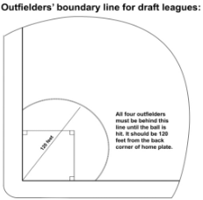

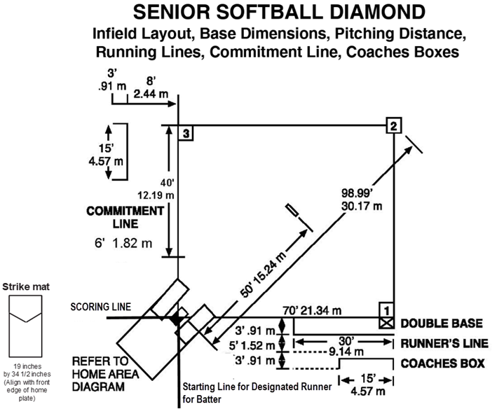
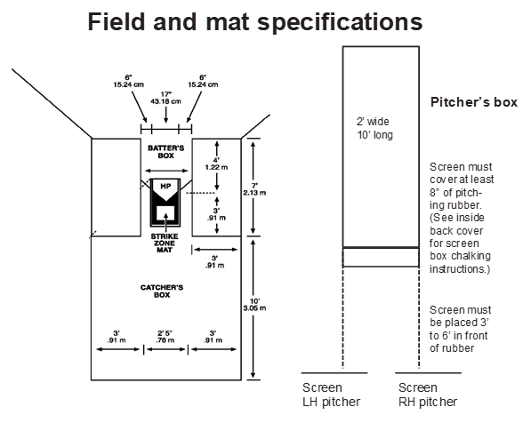
NOTES



