

**Board Meeting Date: Saturday – August 24, @ 1:30 PM**

The Kansas City Metro Senior Softball League Board of Directors met at 6:00 pm, on July 10, 2024, at Susan’s work. 14425 College Boulevard – Suite 120, Lenexa, KS 66215. Present at the meeting were Clint Berger, Bobby Gregg, Susan Scholler, Paul Heacock, Gary Pycior, Barry Gordon, Dave Hendriske, Mark Kenney (on the phone), John Mondi, Ann Willkett, John Dehan (on the phone), Monte Johnson, Jeff Harlan (on the phone), Terry Jackson. Missing Billy Boos.

1. **Call To Order –** Clint called the meeting to order at 1:30 pm.
2. **Read / approve minutes from July 10th - 2024 meeting –** Motion was made by Johnson to approve the minutes, seconded by Susan. Passed 14-0-0.
3. **Treasurer’s Report –** Paul sent out them reports. Paul is going to set up an inventory account to not shock our accounting system. He also suggested for the All-Star game we look at hiring a company to cook and clean up. We will talk about this later. Paul will put together a proposal for this. Right now, the books look like we have more due to not getting invoices from the various Parks & Recs. A motion was made by Scholler to accept the Treasurer’s report, seconded by Gregg. Passed by 14-0-0
4. **COMMITTEE REPORTS** [Default is “No Report” -- unless indicated with an “**R**”, for Report]:
5. **All Star Games / Picnic I. Manager’s / Player’s Survey Q. Rules & Protests**
6. **Awards J. Marketing + Draft**
7. **Board Nominations K. Membership Database / Dues + Men’s Competitive**
8. **By Laws L. Military Service Wall + Women’s & Co-Ed**
9. **Equipment / Safety / Health M. Mission Statement / Goals R. Social Media**
10. **Finance N. New Members / Welcoming R S. Special Projects**
11. **Legal / Risk Management O. Operations Notebook T. Sportsmanship**
12. **Long Range Planning P. Player / Team Ratings U. Tournaments V. Umpires**

**N. Membership – Barry** – we have 121 new members this year. We currently have 960 members. At the same time last year, we had 965.

1. **OLD BUSINESS:**
2. **Wes Weddle RFP update – tournament at the Homefield-Legends complex (Hendrikse) –** Dave asked if we have a preferred time frame – yes, middle to the end of June. Jackson asked, what is the benefit of being associated with SSUSA. If you schedule a tournament at the same time as SSUSA or other organizations, we lose out. Hendrikse will proceed with the RFP. Per Berger, we are looking at the four fields in Lawrence – Clinton Lake (four field complex). Also, per Scott Hall (Jackson County, MO Parks & Rec), Frank White is booked a year in advance on the weekends. We would not be able to play on Saturday and Sunday, so a no go at Frank White. We would be able to play there on Thursday and Friday, if we wished, but not the weekend. Berger also talked to Scott Hall about having our Monday & Thursday draft teams play at Frank White during those days. Gordon and Berger talked to Scott about this so he is going to get a proposal together. There are a few things that could make a big difference. Will players be willing to drive the extra miles. Is the set up at Roe Park for several days a package deal, will it make a difference if we do not play all the current nights?
3. **Alternate Self Storage Location (Berger) –** Clint – all items have been moved to the barn, except the balls which are in our new climate-controlled location – Blue Sky Self Storage, 12252 Metcalf Ave, Overland Park, KS 66213.
4. **All-Star Games / Picnic – Recap (all involved) –** Heacock – our net balance from this event in 2023 was $2,577.00, this year the net balance was $1,341.00. Need to adjust the skills contest so that we are on more than just one field. The hitting proficiency and pitching accuracy events were diminished by the time needed for the home run derby. Gregg also suggested we consider having this event in the fall.
5. **SSUSA’s Supplemental Insurance policy coverage (Heacock, Curley) –** Mike and Paul had a call with an insurance broker. No one is totally sure as to what is covered or not covered. If it is not sanctioned, it is not covered. We also signed a broker of record, so that they can shop and look at our policy. They are going to talk to SSUSA and look at a competitive policy. Paul could not get any more information out of it. We are not completely sure what we are getting for the $45.00/team policy. More to come on this.
6. **72 Hours of Baseball (John Mondi / Bill Boos, Jerry Weaver update) –** John Mondi (per Jerry) is doing a great job organizing the teams. Very excited about what they have going on. It will be a win-win situation for all. There will be a lot going on for the entire 72 hours – from noon on Friday, August 30th, thru Monday noon – September 2nd, at Macken Park -- 1002 Clark Ferguson Dr, North Kansas City, MO. Going to have some local new stations there to cover the happenings.
7. **“Day at the K” (Susan Enyeart update) –** Clint – As of this morning we have about 70 tickets sold for the game between the Royals and the Minnesota Twins. You can purchase tickets up to 6:00 on the the day of the game – Friday, September 6th, 7:10 PM.
8. **Heat-out, etc., guidelines - Committee Decision and Survey Monkey update (Dehan) –** John Dehan said 29 people responded to his Survey Monkey survey, of which 26 said they were comfortable playing under our newly-adopted guidelines. If “AccuWeather” reflects a “Real Feel” temperature in the sun, of 100 degrees or more for your location at the time of the ball games, all games will be cancelled, no questions. 99 and lower, it will be up to the coordinators to make the call. Several Co-coordinators suggested that they check with managers to get some input to make the decisions.
9. **NEW BUSINESS:**
10. **Candidate listing for board nominations (Berger / Pycior) –** Berger – We need to have the board nominations done by the end of September. Currently Mike Curley, Bob Fama, Ed Soltz, Jack Allen, Susan Enyeart & Duane Pitze.
11. **BSN “Sideline” Store (KC Metro items to purchase, similar to our current “Online” Store) – I suggest, for board meeting discussion, you click this link to preview what BSN is offering – PRIOR TO OUR BOARD MEETING:** [**https://sideline.bsnsports.com/**](https://sideline.bsnsports.com/) **10% kick-back at no cost to KC Metro** – Suggested we put them on our website. Do not think we are going to have a big change from what we are currently doing. John Dehan suggested talking to them about team uniforms. He will check with a couple of his friends and see where it can go. John and Clint will talk later.
12. **Board Appreciate Event – Wiffle Ball / Picnic – Sunday - 9/8/24, 1-4 PM - 239 W 52nd St, Kansas City, MO 64112 – see aerial view below (Gordon) -** The list has been made up of board members, coordinators and others that have assisted the league throughout the year.
    * **Monetary Donation??**  Joe Ungashek normally charges, any group utilizing his wiffle ball field, $350 for its use. Joe has requested we agree to donate our $350 to “The Battle Within” charity. Barry made a proposal that we agree to Joe’s request. Seconded by Clint. Passed 14-0-0.
13. **Wes Weddle, Rookie of the Year, Ambassador Awards (Gordon) –** Barry asked that we all make the efforts to get this information out to all coordinators and managers ASAP.
14. **Look for a new assignor for umpires.** John Dehan has officially given his 2-year notice. He will be shutting down his Call The Game business, or selling it to someone else. He is not sure, if he sells it, as to whether, or not, the new owner would want to continue to have us as one of their customers. We will need to get someone to assign umpires for our games. We need a replacement by the 2026 season.

**Items desired to be included in August Newsletter email blast (BOARD preferences / suggestions)**

**SET DATE FOR NEXT MEETING** (suggestion….) September 22, 2024, at 1:00pm at Susans work. Teams meeting will be available for those who cannot make it in person.

Susan made a motion to adjourn the meeting at 3:25. Seconded by Ann. Passed 14-0-0

**239 W 52nd St, Kansas City, MO 64112**

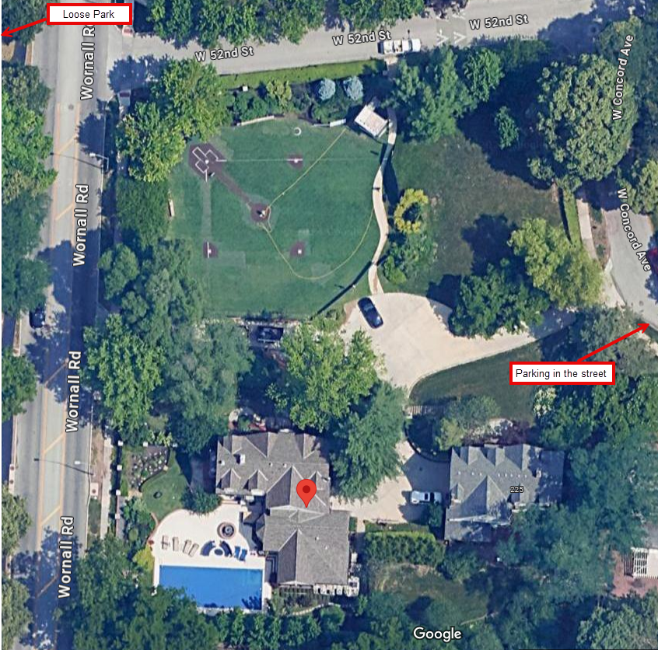

**2024 2025 2026**

Dave Hendrikse Clint Berger Barry Gordon

Jeff Harlan Bill Boos Bobby Gregg

John Mondi Ann Willkett John Dehan

Gary Pycior Paul Heacock Susan Scholler

Terry Jackson Mark Kenney Monte Johnson