HALL OF HONOR

CHUCK BUA - 2018
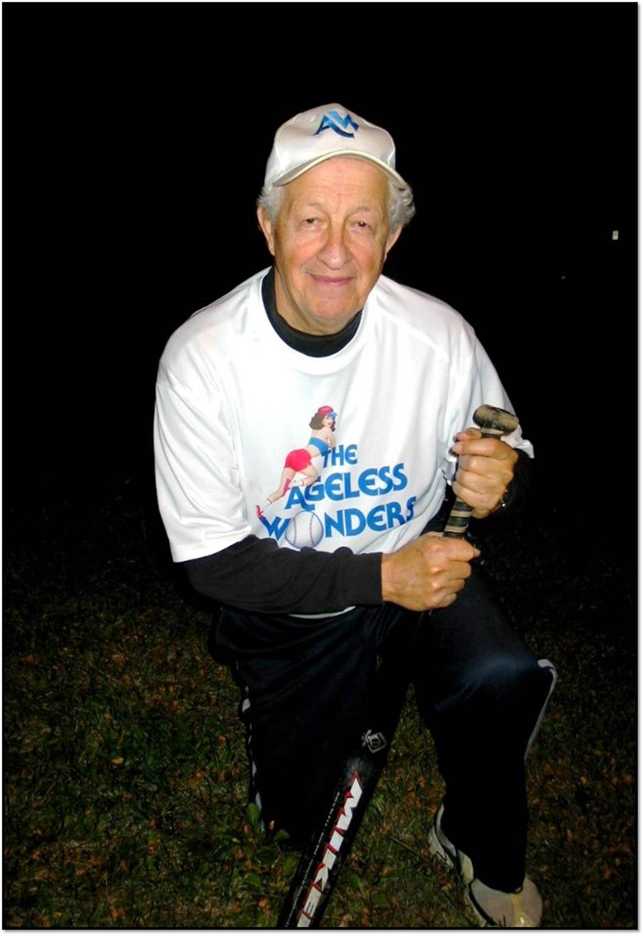
A founding member of the KCMSSL, Chuck Bua started with the organization in 1989 and played in its initial league game in 1990. He was an early member of the Board of Directors. His art skills and creativity were instrumental in helping promote and grow the league for nearly 30 years. He continually recruited new players as well. Though perhaps best known as the founder/long-term manager of the Ageless Wonders, he also managed a number of “draft” teams in various venues across the Kansas City area.
In November 2016, Chuck suffered a massive stroke that left him bed-ridden 24/7. His competitive spirit keeps him fighting for his life. When he received this award in 2018, he resided at Fulton Commons Care Center in Long Island, N.Y.
Video of Chuck being notified of the Hall of Honor award:
https://vimeo.com/297172595/706fc64cb3

JIM CUNNINGHAM - 2018
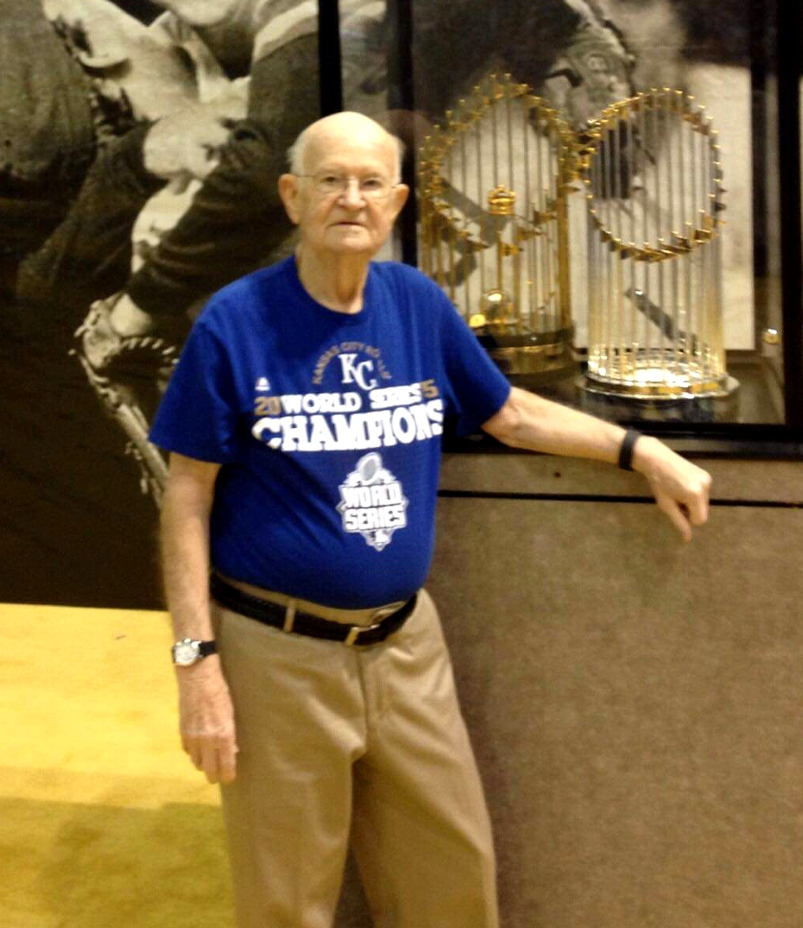
A long-time member of the KCMSSL, Jim served on the Board of Directors and was the league treasurer for several years. He always was among the first to volunteer at the picnics, at tournaments and for other league needs. It was Jim’s idea to start the woman’s conference, and he worked very hard to get it going.
Jim also founded the KC Diamonds, which has been a competitive men’s team in our Thursday night conference for many years. Through the Diamonds and the women’s conference, Jim brought many new players into our organization.
Jim truly loved the game of softball and this association. Above all, he was a good friend to everyone, a great sportsman and a true gentleman.
Jim, who died in 2018, is missed by the many people whose lives he touched.

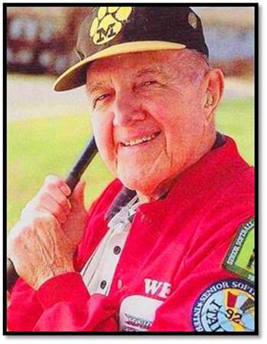
Wes Weddle - 2018
Without Wes Weddle, our organization would not exist. He founded the Kansas City Metro 50+ Senior Softball League in 1989, launched the first season with three teams in 1990, continually recruited new members, and repeatedly obtained television, radio and newspaper coverage to help the KCMSSL grow into what now is the largest senior softball league in the country.
Wes served as our president for 17 years and then as president emeritus until his death from cancer in 2013. A true gentleman, he treated everyone with respect, and in turn, he expected all players to be civil on the field. Sportsmanship mattered.
Wes also was known for his love of MU athletics and his mentorship of many youngsters during a 38-year career as a teacher and school principal in Kansas City. A Navy veteran of World War II, he often leaned on his wife, Ethel, to help with KCMSSL league activities and even to fill in playing on short-handed men’s teams in the league’s early years.
It was his love of the game that allows all of us to keep playing today.

