RATING CHART EXPLANATION:
Our player skill rating scale will “range” from 10-thru-1. 10 will be the highest rating, and 1 the lowest…….with 10-9 being reflective of a platinum player’s range, 8-7-6 being Gold, 5-4-3 being Silver, and 2-1 being Bronze.

With that in mind, let’s say we’ve baseline-rated one of our members, John Doe -- a 70 year-old player, as a "7"…….based on his overall 5-tool skills, etc., compared to all other male players in our organization who are 70 years old, or right around there.

This rating is John’s “baseline” rating, and places him in the middle of the Gold player scale. John’s baseline rating does NOT change unless he appeals it (and is granted the appeal), or if the KCMSSL Player Skill Rating committee -- as a committee -- changes that rating for whatever reason(s). Based on his “7” rating, as an example, John would remain a Gold rated player in our newly-proposed 70+ hybrid conference in 2018. He would be playing in a conference mirroring his age, so there would be no tiered-down adjustment made to his rating. See illustration below.
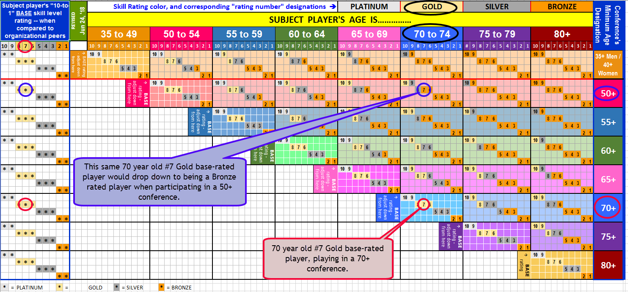

Any “tiered-down” rating adjustment for John goes into effect when he participates in a conference where the minimum age requirement for that conference is at least 5 years under John’s actual age. In each of those conference-by-conference instances, Leaguesheets will automatically, and proportionately, tier-down, or step-down, John’s rating. The KCMSSL Player Skill Rating Committee does not concern itself with whatever conference John plays, or “in what division” within that conference he plays, or even on what team he may wish to play within that division. Leaguesheets will take care of making all such applicable adjustments based on John’s baseline rating relative to his age, and then relative to each conference’s minimum age requirement.

Each player’s rating – whether baseline, or tiered-down -- will accompany the player’s record, and be shown on each team’s roster as the manager goes through the process of adding players.

All rosters will be allotted a combined maximum of 3 players whose applicable rating – whether baseline, or tiered-down -- is the next skill level rating above the team’s rating.

In other words, a Bronze rated team will be allotted a “combined maximum” of 3 Silver rated players – whose baseline, or tiered-down rating, is Silver – on its roster. If the manager attempts to add a 4th Silver rated player (whether baseline, or tiered-down) to that roster, the system will not allow the addition to occur. The manager will be shown an error message at the time the addition is attempted, making him aware of that fact. The manager, at that point, has a few known options.
- The new 4th Silver player does not get added; or
- 1 of the previously-added Silver player has to be dropped -- allowing a spot for the new Silver player to be added; or
- the manager can request for the team to be rerated as a Silver team (thus allowing for an even greater number of Silver players to be added).
Rerating any team to a new classification requires coordination with the subject conference coordinator…..since shuffling, or rearranging of other teams may need to be addressed. Odds are such a change would not be allowed in mid-session.

Now that you’ve reviewed this information, if you have suggestions / ideas as to how this system / process could possibly work better, by all means share your thoughts with any member of the KCMSSL board for discussion purposes.

Note: SSUSA does not rate this way. They rate teams. SSUSA cannot, conceivably, mirror our rating process due to the much-wider range of players’ ages we have in each of our conferences compared to the more-compact age parameters for SSUSA’s tournament teams. A 50+ SSUSA tournament team is going to be primarily comprised of players 50 to 55 years of age. Routinely once tournament players on a 50+ team turn 55, they start to filter-up to playing on a 55+ team, or the team moves up to 55+ as soon as enough players qualify for that division. And so forth for teams in the other SSUSA tournament team divisions. In contrast, it’s not unusual for any of our KCMSSL teams to have multiple 70+ year old players on their 50+ conference team rosters. Nor is it unusual for 80+ year old players to be on team rosters in our 60+ conferences. Etc., etc. We’re simply a different animal.

Additionally, our membership number is a fraction of SSUSA’s membership. It would, therefore, be almost impossible for SSUSA to individually know each one of their members in order to properly rated each one.

